Lot Genius
Architecture Reference
Steffes Group internal AI agent for auction-data lookups.
For full-stack engineers joining the project.

Last updated: 2026-05-05 • Tenant: Steffes Group, Inc.
Subscription: Pay-As-You-Go (e1c620c2-...)
Resource group: rg-steffes-copilot

1. What Lot Genius Is
Lot Genius is an internal Steffes Group AI agent that lets auction appraisers ask natural-language questions about historical auction data and get conversational answers backed by real SQL queries against Synapse.
It is a chat agent, not a dashboard or report tool. Appraisers use it the way they'd use a knowledgeable coworker who happens to have every lot Steffes has ever sold memorized.
Sample queries
- Show me 5 comps for a 2023 John Deere X9 1100
- What's the year-over-year hammer price trend for combines?
- Find me the top 3 descriptions for a JD S790 by sale performance
- Comps for a 2018 MFWD tractor in Iowa
The agent surfaces inside Microsoft Teams and Microsoft 365 Copilot — wherever Steffes employees already work.
2. Target Users
Audience | Where they hit the agent | What they use it for
Appraisers (primary, ~10–20 users) | Teams chat, M365 Copilot agent picker | Comparable sales, equipment valuation, description scoring, sales-trend analysis
Operations / Admin (1–2 users) | /api/admin/ web console | Tuning prompts, curating make/model aliases, managing PII column lists, reviewing user feedback
External / public | Not exposed | Tenant-internal only; no public access

Access to the agent is gated by Microsoft Entra SSO (tenant membership). Access to the admin console is further gated by membership in the Lot Genius Admins Entra group.
3. High-Level Architecture
Five layers, three identity boundaries. The diagram below shows the runtime path a single user question takes from chat client to data store and back.
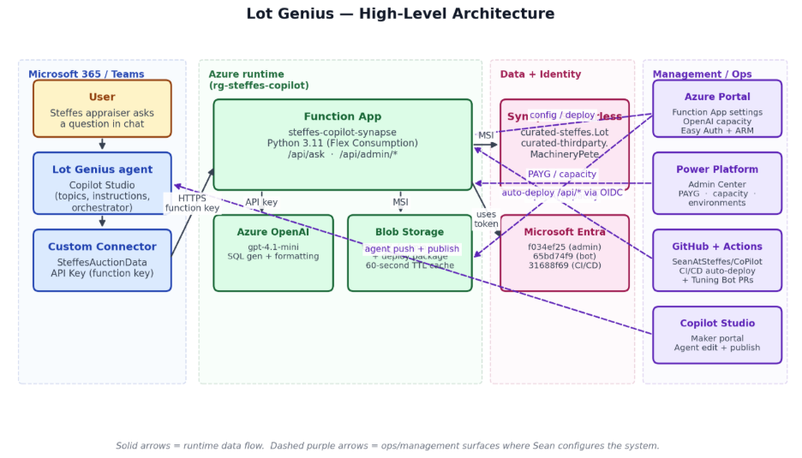
Figure 1 — Lot Genius high-level architecture
One-line summary: Copilot Studio agent → Custom connector → Function App /api/ask → (gpt-4.1-mini for SQL generation) → Synapse Serverless SQL → return prose to user.
4. Conversation Flow
When a user types a question in Teams, here's what happens end-to-end:
- User sends the message in Teams.
- Microsoft Teams + M365 Copilot route it to the Lot Genius agent based on the installed Teams app and agent metadata.
- Copilot Studio's orchestrator picks the right topic by matching trigger phrases and modelDescription against the user's text. Comp questions land in CompsAndAppraisal.
- The topic captures the user's text into Topic.Equipment, detects whether a year is mentioned, and sends a 'criteria proposal' message asking the user to confirm scope (year range, geography, sales period).
- User confirms. The topic builds an explicit question for the SQL bridge and invokes the AskAuctionQuestion action (the custom connector).
- The connector calls GET /api/ask with the function key. The Function App generates SQL via gpt-4.1-mini, runs guardrails (PII check, comp-context guard), executes the query against Synapse via Managed Identity, and returns JSON with rows + filter notes.
- The agent's gpt-5 orchestrator reads the JSON and the agent-level instructions (anti-fabrication, currency display) and writes a human-readable answer for the user.
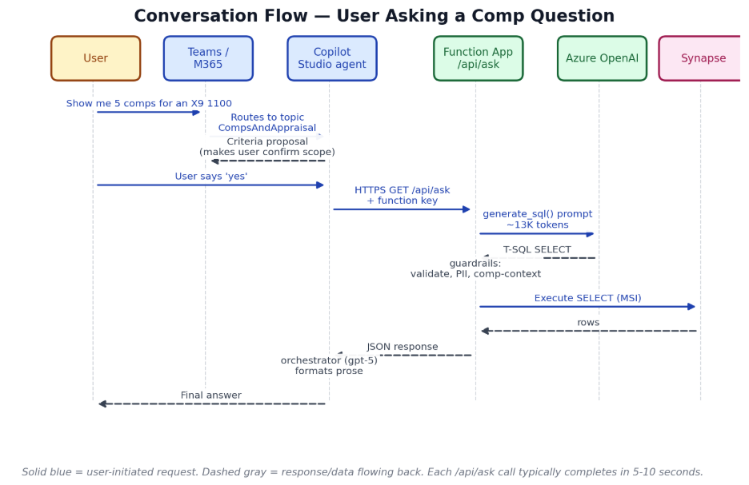
Figure 2 — Conversation flow for 'Show me 5 comps for an X9 1100'
Important variations
Tier-widening. If the first SQL returns 0 rows, the topic offers to widen the search (2y → 5y, then exact-model → variants). User confirms each tier.
Suggestions menu fallback. When the orchestrator can't route a message, the Fallback topic invokes SuggestionsMenu, showing 6 category chips (comps, appraisals, trends, descriptions, 3rd-party, other).
Anti-fabrication rule. The agent's instructions forbid inventing values when a field is missing — never substitute the current year for an unknown year.
5. Authentication
Lot Genius has multiple identity boundaries, each with its own auth mechanism. New engineers tend to conflate them — don't.
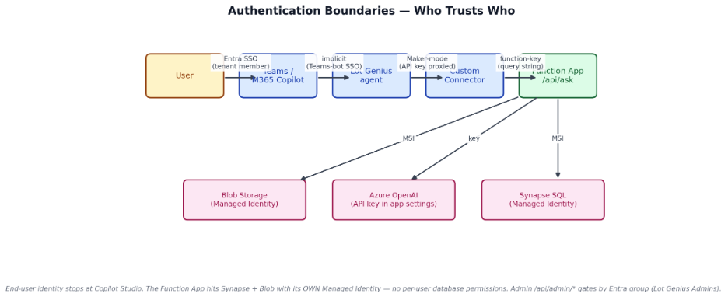
Figure 3 — Authentication boundaries
Hop | Mechanism | Notes
User → Teams / M365 | Microsoft Entra SSO | Standard tenant SSO; outside our control
Teams → Copilot Studio agent | Implicit (bot SSO) | Bot Entra app 65bd74f9-... trusts the user's token
Copilot Studio → Custom Connector | API Key (Maker mode) | Sean's stored function key is used for ALL users — no Entra impersonation
Connector → Function App /api/ask | function key (?code=...) | /api/ask is in Easy Auth excludedPaths
Function App → Synapse | Managed Identity | All queries run as the Function App MSI; user identity not propagated
Function App → Azure OpenAI | API key (app setting) | Could move to MSI in the future
Function App → Blob Storage | Managed Identity | Storage Blob Data Contributor on tuning/ container
User → /api/admin/* | Easy Auth + group claim | Must be in Lot Genius Admins Entra group; @require_admin Python decorator re-checks defense-in-depth
GitHub Actions → Azure | OIDC federation | Lot Genius CI/CD app 31688f69-...; Owner on Function App scope only
GitHub App → repo | JWT + installation token | Lot Genius Tuning Bot; opens PRs from /api/admin/pr/{surface}
6. Data Layer
Lot Genius queries four Synapse Serverless tables. The Lot table is the primary search target; the others are joined or referenced as needed.
Table | Approx. rows | Purpose | Notes
[curated-steffes].Lot | ~500K | Main fact table — every Steffes lot ever sold | 481 columns; PII columns blocklisted
[curated-thirdparty].MachineryPete | ~100K | 3rd-party comps from MachineryPete | Currently UNUSED at runtime — MP_COMPS_ENABLED=false
[curated-steffes].Category | small | Category hierarchy lookup | Used for hierarchy expansion (Tractors → 2WD, 4WD, MFWD, …)
[curated-biggerpicture].Lot | ~100K | Pre-acquisition BiggerPicture lots | Fallback comp source

External data is reached via Synapse external table → ADLS Gen2 → Delta Lake, using the workspace's managed identity credential. Function App MSI has SELECT on the curated views only; no direct ADLS access.
7. Tuning & Admin Console
Most behavior changes don't require a code deploy. Six tuning surfaces are exposed through the admin console; four go live in 60 seconds, two open GitHub PRs that take effect after merge + redeploy.
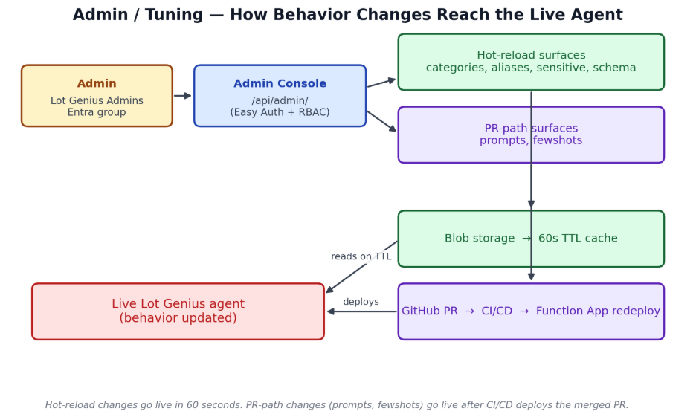
Figure 4 — How admin changes propagate to the live agent
Hot-reload surfaces
Categories. Curated category overrides for hierarchy expansion (e.g., 'Tractors' → 2WD/4WD/MFWD/Track/Collectible Tractors).
Aliases. Make-name aliases (e.g., 'CAT' → 'Caterpillar').
Sensitive. PII and sensitive column blocklist beyond the baked-in floor.
Schema. Lot column visibility — which columns appear in the prompt's schema block.
PR-path surfaces
Prompts. function_app/prompts.py — the system prompt for SQL generation and the formatter.
Fewshots. function_app/fewshots.json — curated query examples appended to the prompt.
Edits open a PR from lot-genius-tuning-bot[bot] against SeanAtSteffes/CoPilot. After PR merge, GitHub Actions auto-deploys the Function App with manual approval at the production environment gate.
8. CI/CD & Deployment
Function App
- Trigger: push to main touching function_app/**, or manual workflow_dispatch.
- Test job: pytest with --timeout=30; xfailed list of pre-existing failures parked in conftest.py.
- Deploy job: gated by GitHub Environment 'production' (manual approval); uses azure/login@v2 with OIDC; runs `func azure functionapp publish steffes-copilot-synapse --python`.
- Auth-config self-heal: snapshots authsettingsV2 before deploy, re-applies after (defends against `func publish` Easy Auth wipe).
- Smoke checks: /api/health returns 200, /api/admin/ returns 302/401 (still gated).
Copilot Studio agent
Manual deploy via the Copilot Studio Manage workflow. The agent's YAML lives at Clone/Lot Genius/. Push and publish are separate operations; admins push to draft, test in Studio canvas, then publish to make changes live in Teams / M365 Copilot. There is no GitHub Actions automation for the agent today.
9. Operational Notes
Capacity
Resource | Current | Notes
Azure OpenAI gpt-4.1-mini | 1000 capacity / 1M TPM | Quota cap 5M TPM; ~77 RPM at typical 13K tokens/req
Function App scaling | 1 always-ready, max 100 instances | Flex Consumption, 2 GB memory each
Copilot Studio Messages | PAYG via copilotstudiobilling resource | Overages billed per-message to linked Azure subscription
Synapse Serverless | shared compute (no fixed reservation) | Per-query latency 5–12 seconds typical
Troubleshooting cheat sheet
Symptom | First place to check
Agent says 'usage limit reached' | Power Platform Admin Center → Pay-as-you-go (capacity / billing)
30s connector timeout | App Insights → recent /api/ask durations; check MP_COMPS_ENABLED
'I'm having trouble right now' | App Insights for OpenAI errors; check Azure OpenAI rate limits
Admin console 'forbidden / 403' | User isn't in Lot Genius Admins Entra group
PR merged but change not live | Did it touch function_app/** (auto-deploys) or Clone/Lot Genius/** (requires manual Manage push)?
Agent invents data | Check agent.mcs.yml instructions for anti-fabrication block; check prompts.py Rule 30
Tuning edit not picked up | Wait 60s (TTL cache); if still stale, hit /api/admin/tuning/reload
10. Glossary
Topic. Copilot Studio's name for a conversation flow (a state machine of nodes).
Action. Copilot Studio's name for an external integration call (custom connector, generative answer, etc.).
Maker mode. Connector mode where the agent owner's stored credential is used for all calls.
Invoker mode. Connector mode where each user's own delegated credential is used.
Hot-reload surface. A tuning surface that writes to blob storage and is picked up by the agent within 60s without a deploy.
PR-path surface. A tuning surface where edits open a GitHub PR; takes effect after PR merge + redeploy.
MSI. Managed Service Identity — system-assigned identity on the Function App used to authenticate to Synapse and Storage.
MP / MachineryPete. A third-party auction data source (currently unused at runtime — see MP_COMPS_ENABLED).
PAYG. Pay-as-you-go billing for Power Platform — overages billed per-message to a linked Azure subscription.

